IP Address of GUVI (in IPV4)

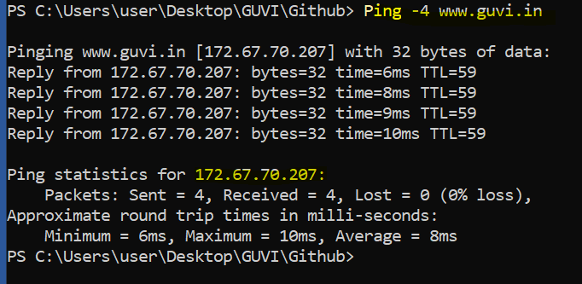

To grab the real time uses of CPU, Memory & other components

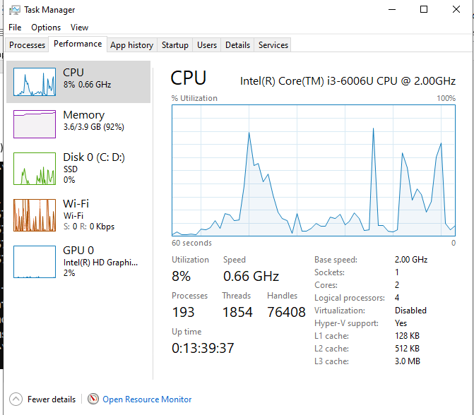

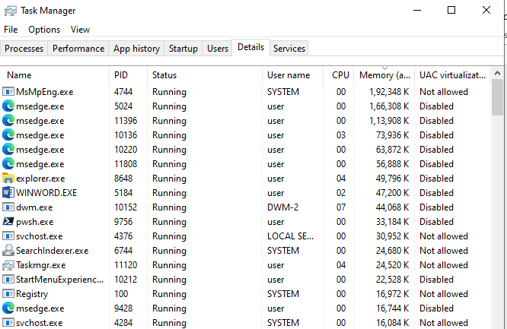

There are more ways to git it as can use PowerShell or top commands in UNIX infra.

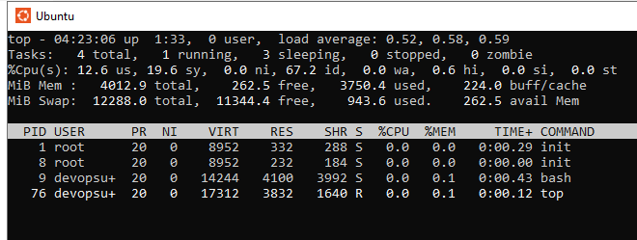

Free -h command see memory free

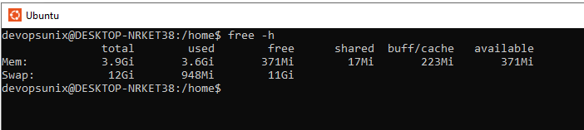

To test the port statu we use following action

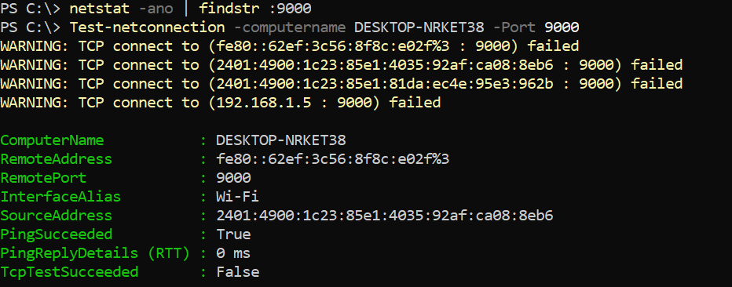

Running test to see the active connection by using the netstat and telnet & Test-Netconnection are ways to validate if the system ports are enabled.